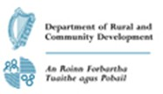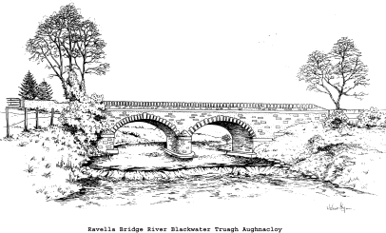

JOB DESCRIPTION
Job Title: Part-Time Catering Assistant (19.5 hrs per week)

Reporting to: Management, Truagh Development Association CLG Community Services
Programme.
Job Purpose: Your role as a Catering Assistant is to help in preparation of food and to take care of all aspects of hygiene in the kitchen.

Main Duties & Responsibilities

- To provide support in the preparation and presentation of all foods in the kitchen.

- Assist in the preparation and serving of foods.

- Ensure kitchen facilities are maintained to a high standard including fridge, freezer, dry goods store, ovens, food preparation areas, sinks and floors.

- Continually address and implement good food hygiene requirements for food catering operations.

- Work effectively with other staff in the team

- To support the development of the catering section within the Community Services Programme

- Setting-up of main hall, reception area for functions, school lunches and other activities. This will include ensuring floors and windows are maintained to a high standard, setting-up of tables.

Team work

- To work effectively with Management and Staff of the Community Services Programme to ensure high standards of services is provided and achieved at all times

- Maintain a good working relationship with Management and Staff

Additional

- To perform any other reasonable duties

- Flexible working hours

Job Specification

Essential Skills:

- Experience in catering, bakery or hospitality sectors

- Good food management skills in relation to food catering operations

⇒ Storage, preparation of foods, cooking and serving skills
⇒ Awareness of temperature control for various foods e.g. fridge/freezer
⇒ Managing stock deliveries inward and outward
- Good workplace Food Safety & Hygiene knowledge

- Good Personal Hygiene knowledge

- Good time management

- Excellent food presentation skills

- Flexible approach to working including evenings and weekends

- Good communication skills

- Ability to work to own initiative

Desirable Skills:

- Qualification in Catering and/or Cookery Certificate/Culinary Skills

- Hold a basic Food Hygiene qualification

- A full driver's licence & access to transport

Personal Qualities

The successful applicant will be self-motivated and dynamic and have a commitment to Catering and Hospitality within a community setting. You will have a strong commitment to the aims and objectives of Truagh Development Associations’ Community Services Programme.

Location: Blackwater Valley Learning Centre

